Analyzing, Understanding, and Replicating Pipe Organ Tremulants with Soundfonts and jOrgan
First, find a tremulant you want to imitate and record it in action. I’m working on a virtual version of the Kaat en Tijhuis Kandelaar organ, an organ built in 1989 in a French Baroque style. I couldn’t find any recordings of that organ’s tremulants, but I found this recording on YouTube of a Taylor and Boody organ, built recently in a similar style. Here’s the recording (which is also informative on how real tremulants work). The recording isn’t of highest quality, but gives us the information we want:
http://www.youtube.com/watch?v=elt5dujVc5o
I made an audio recording with Audacity of a section around 2:14 to 2:20, normalized the volume, and then stretched the volume level (with “Volume Envelope) so that the max volume of the recording was at 1.00.
Tremulant Pitch
First I do a rough looping of several cycles and play it while watching a tuner. (I use GTune.)
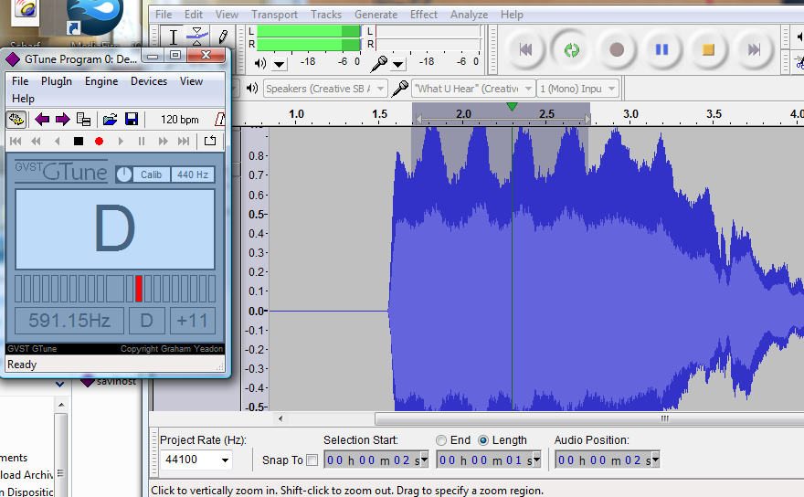
The pitch is +10, and the tuner appears to wobble between +10 and +11.
Tremulant Frequency
There are two ways to determine frequency of a tremulant. Counting cycles in a second and measuring the length of a single cycle.
Look at the highlighted portion of the recording:
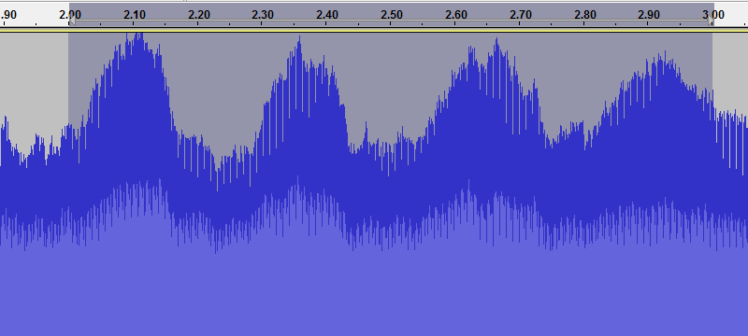
In the recording between 2.00 and 3.00 seconds we see that there are four spikes and three troughs. If we’d move our selection back to the bottom of the first trough, we could estimate this tremulant at around 3.6 Hz.
Next I selected just one cycle of the tremulant, from trough to trough.
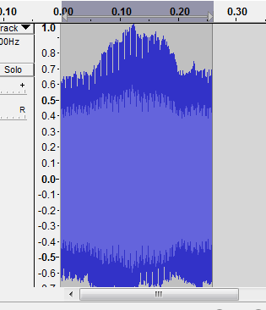
Expand the view to get the most precise measurement possible:
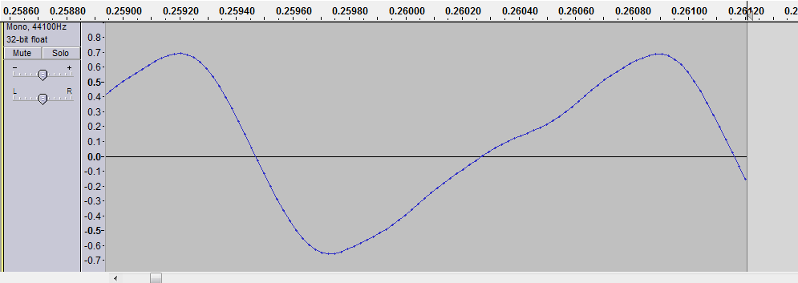
We see that one cycle is 0.261 seconds long.
1 / 0.261 = 3.83 Hz. A little faster than our first estimate.
Tremulant Depth (Volume variance)
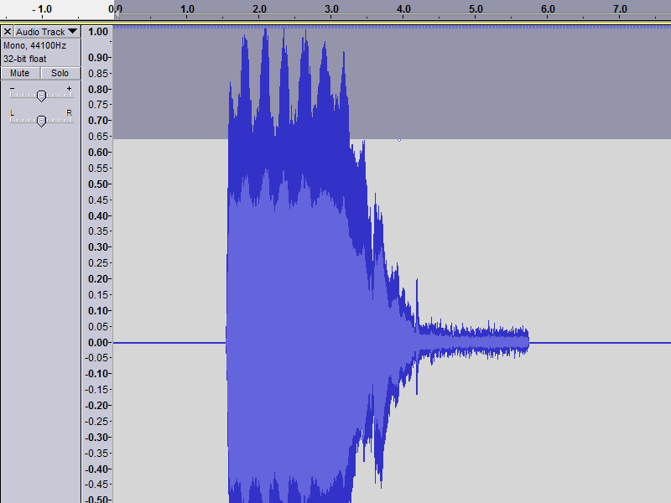
Notice first that the low point of the volume is between 0.65 and 0.70. (Let’s say it’s 0.67). That gives us a pitch variance of about 0.33 between maximum and minimum. This would be “Tremulant depth.” It’s a variation in volume or wave amplitude.
Replicating the tremulant with the new modulated tremulant settings
First, the CC controllers must be enabled/installed on the instrument level in the soundfont.
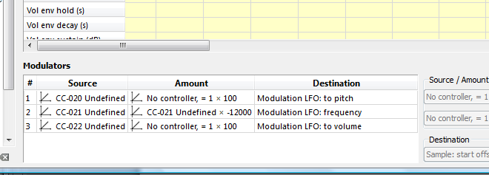
Then in the disposition, make a switch filter with messages for CC20 to CC22
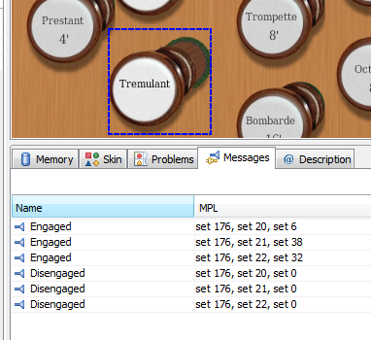
We determined the Taylor and Boody tremulant had a pitch variance of +1, a frequency of 3.83 Hz, and a depth of 0.33.

Charts:
Pitch (Cents) | CC 20 (range 0-127)
100 | 127
50 | 64
25 | 32
The formula for pitch is multiply pitch in cents by 1.27 to get the CC20 setting.

Frequency (Hz) | CC 21 (range 0-127)
7.00 | 19
6.88 | 20
6.76 | 21
6.64 | 22
6.51 | 23
6.38 | 24
6.25 | 25
6.11 | 26
5.98 | 27
5.84 | 28
5.70 | 29
5.55 | 30
5.41 | 31
5.27 | 32
5.12 | 33
4.97 | 34
4.83 | 35
4.68 | 36
4.54 | 37
4.40 | 38
4.25 | 39
4.11 | 40
3.97 | 41
3.83 | 42
3.69 | 43
3.56 | 44
The formula to convert CC 21 value to frequency:
Set 20 --> Value = (20/127)*(20/127)*(-12000) = -298 --> 2^(-298/1200)*8.176 = 6.88 Hz.
Volume Variance amount of total volume | CC 22 (range 0-127)
0.05 | 10
0.10 | 20
0.20 | 30
0.30 | 40
0.45 | 50
0.45 | 60
0.48 | 70
The formula for volume is multiply volume variance by 127 to get the CC22 setting.

So, back to our readings from the Taylor and Boody recording:
Pitch variance: +1 +1 x 1.27 = 1 (MIDI command 20 doesn’t take decimals.) Round it up to 2.
Frequency: 3.83 Hz, use 42 as the setting.
Depth: 0.33, use 42 as the setting.
Play. Listen. Compare. Frequency may not need adjustment. Tremulant pitch variance may need to be increased because our tuner may not be fast enough to fully capture the variance in the original recording. Depth may need reduction because of the acoustics of the room where the original recording was made.
It’s good to remember that the reverberative environment has a great effect on the sound of a tremulant, especially in the perception of depth. With a pitch variance, a depth variance will be perceived and heard, even if tremulant depth is set at zero.
As they say in cookbooks, adjust to taste.
To Make a Tremulant with Continuous Filters
Make three continuous filters:

Tremulant Pitch
Engaging set 176, set 20, set value | div 1.01 | add 0.01 | mult 127

Tremulant Frequency
Engaging set 176, set 21, set value | greater 0.1 | mult 127.

Tremulant Depth / Volume
Engaging set 176, set 22, set value | div 1.01 | add 0.01 | mult 127

Reference all three to all ranks that you want to control. Then make two (or more) combinations, reference them to all three of the tremulant continuous filters. Reference a captor (set) to the combinations and use the captor and combinations to store the settings. Have one combination in which you set all three continuous filters to 0.00 for “Tremulant off.”

This method allows the user to test and adjust the tremulant on the fly.

The numbers displayed in the continuous filters have the range 0.00 – 1.00, which will be different from what would be used in a switch filter, which has the range 0—127. Equivalent switch filter settings can be determined from the continuous settings by multiplying the displayed number by 127. For example, a continuous filter’s displayed number of 0.32 multiplied by 127 would give you a setting of 40.64, round up to 41, for an equivalent setting in a switch filter.

Special thanks to Dries, who helped with the mathematics of the frequency settings, to Lars O DelGioio for additional observations, and to Bernd, Davy and others who helped develop the new method of modulated tremulants.

Paul Stratman
Beaver Dam, Wisconsin USA
August 2013

A tremulant system can also be made using continuous filters and the settings can be stored and activated with combinations. See later section.

