Dynamic Wind Simulation with jOrgan
The method described here will enable a disposition to simulate a pitch variance through monitoring of key activity. In this modelling method, sensitivity and recovery time are also adjustable.
Colin Pykett describes some of the challenges of simulating a wind system in his article on Physical Modelling in the section Wind System Modelling. http://www.pykett.org.uk/physmod.htm#WindModel

The Rodgers System, also used by Hauptwerk
Rodgers Organ Company holds a patent (Patent Number 5,508,472) on a dynamic wind simulation. This is the same wind simulation used by the Hauptwerk virtual organ program.
Figure 4 from the patent is displayed here:
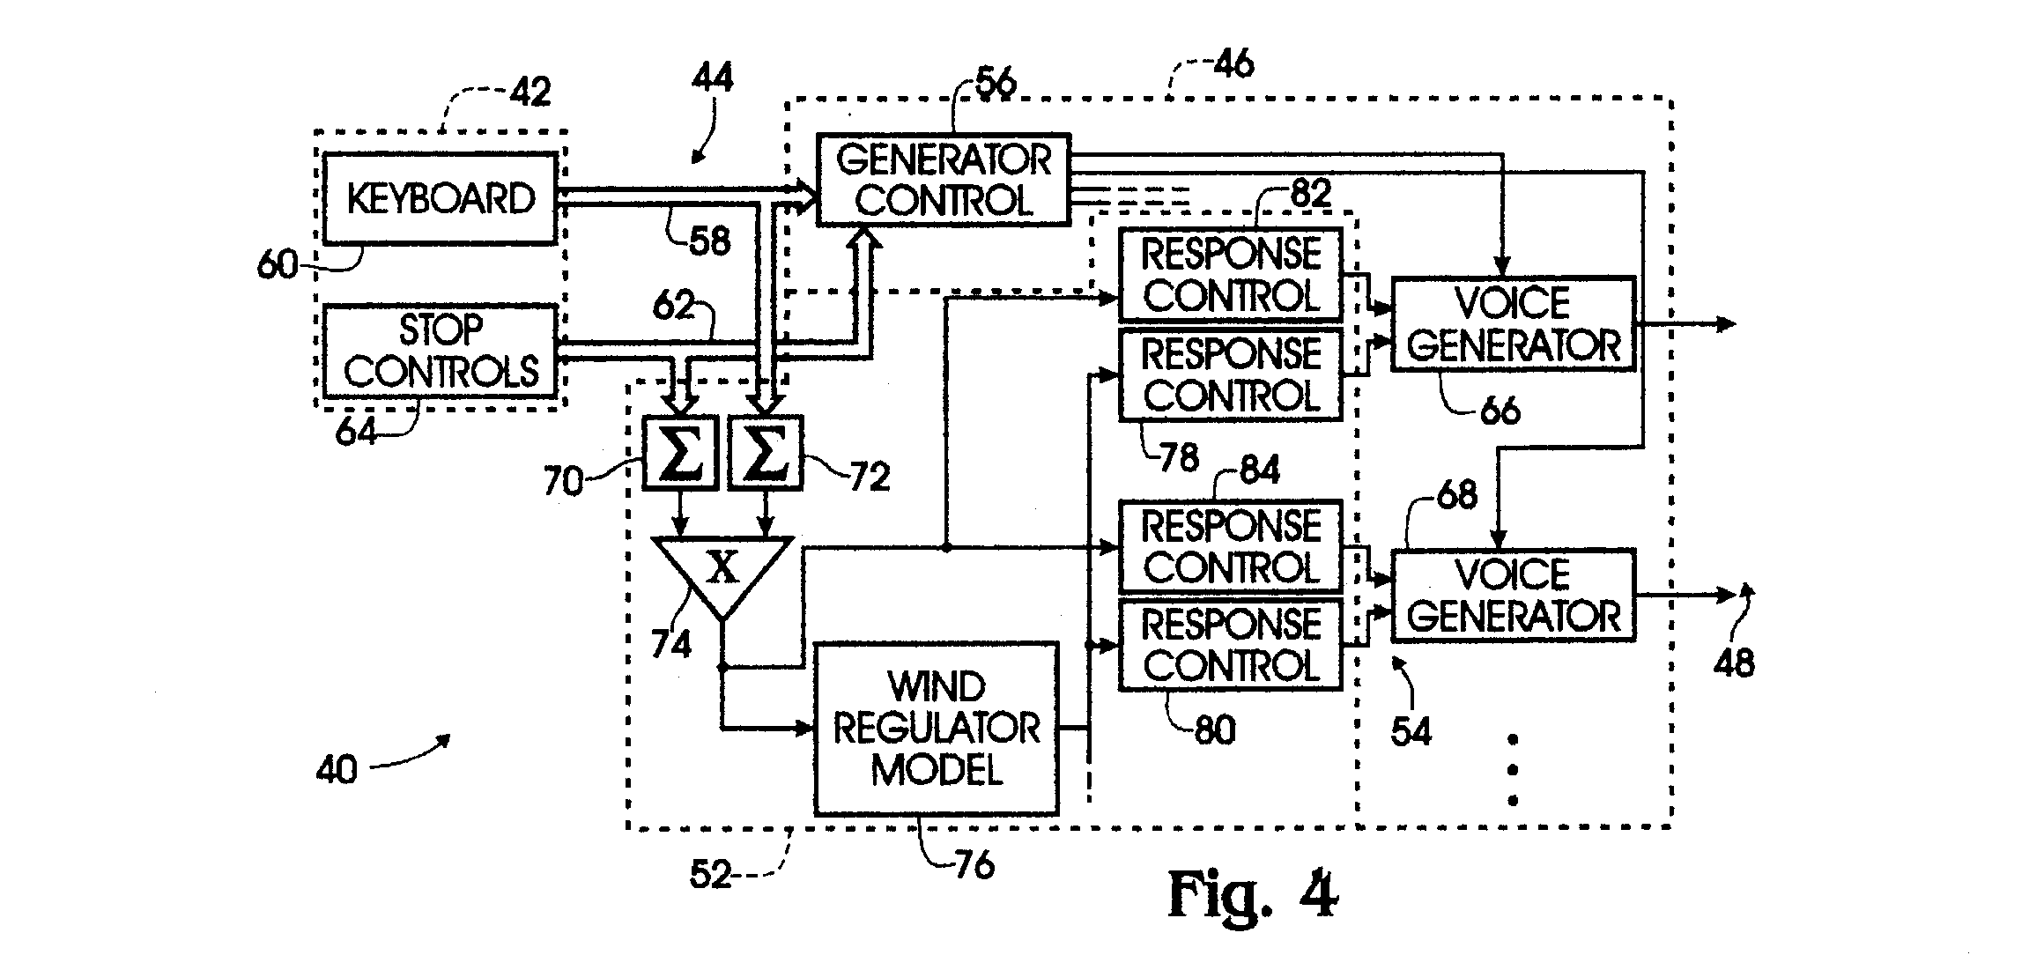
To explain this simply, there are two sources of input, “Keyboard” and “Stop controls. The number of keys depressed is multiplied (x) by the number of stops drawn which then becomes the input into the wind regulator model, which then modifies the voices (Response control).
Later in the patent document it describes variations to this system to make the simulation more accurate. Each type of pipe draws a different amount of air, and causes different degrees of wind variance. Lower flue pipes use more air, so a higher integer is given in the keyboard input for low notes than for high notes. Each type of rank also responds differently to wind variance. Principals respond less, flutes more. Unlike Allen’s “Whind / Random Motion “ and “Voice Articulation” which simply apply an effect to the sounds, this model is a dynamic model which responds to input in real time with a fluid continuous variation of the pitch which is derived from both key and stop activity. Allen’s “Random Motion” (or as we call it, “Wind Destabilization”) and “Voice Articulation” (“Flexible Wind”) are mere static MIDI affects that are applied to the voices.
Allen currently has a similar system called “Air Regulator” with this description:
In a pipe organ, as more stops are played, the winding fluctuates momentarily as the air pressure builds up. This results in interesting sound nuances (pitch fluctuations) that have become an important part of pipe organ sound. With Air Regulator, Allen's digital voices react in this same manner; a very sophisticated, but subtle pipe organ sound nuance.
I couldn’t find any more of a description or a patent.
Johannus has a similar system called pipeLIFE tuning:
All organists know that the musical beauty of a good pipe organ is unsurpassed. Every pipe differs slightly in response, depending on a number of variables. For example, Johannus previously introduced its unique wind pressure activity, which recreates the slight detuning of pipes when larger chords are played. Of course, the degree of pitch sag depends on wind system design, number of keys and type of stops used, with the effect greater on higher pitched pipes and less on larger ones. The depth can be adjusted to a real ‘wind sagging’
pipe organ impression. A great accomplishment in itself, but JOHANNUS has now gone even further! Now the Johannus research team has recreated another unique pipe organ characteristic called pipeLIFE™ Tuning. The tuning of a pipe is seldom exactly the same, even when played twice in succession. The pipes’ pitch is influenced by temperature, wind in the chest, physical layout of pipe ranks as well as which keys are played simultaneously. Pipes in physical and acoustical proximity to one another infl uence each other’s pitch; this
phenomenon is often referred to as ‘drawing’ by professional organ tuners. Johannus pipeLIFE™ Tuning recreates this phenomenon and employs these properties with amazing realism and clarity to create the ultimate pipe-like experience. Another FIRST from JOHANNUS!

A Dynamic Wind Simulation Model for jOrgan
With jOrgan, it currently isn’t possible to have an element that counts the number of keys pressed multiplied by the number of stops drawn to compute in real time a varying integer that in turn controls the pitch. We can, however, monitor key activity using jOrgan’s MIDI merger and have all key activity trigger a switch, much like the Flexible Wind does, only to have it register in a Dynamic Wind Engine. This Dynamic Wind Engine combines elements of both the ”Flexible Wind” and “Wind Destabilization Engine” in a dynamic way that builds the effect in real time as keys are played.
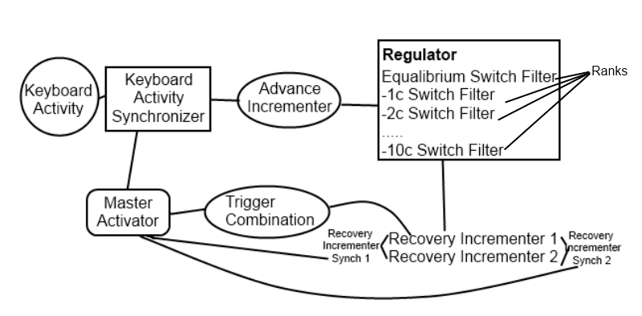
The Dynamic Wind Master Activator is the on/off switch that controls everything and is also displayed on the console.
Dynamic Wind Advance Incrementer moves the pitch downward and is triggered by keyboard activity. If the duration is set low, the Advance Incrementer will be more sensitive, registering all non-simultaneous key presses. If set higher, it will be less sensitive, only registering some of the key presses within the duration specified.
The Dynamic Wind Recovery Incrementer Trigger Combination initiates activity with Dynamic Wind Recovery Incrementer 1. Dynamic Wind Recovery Incrementer Synch 1 and 2 are set to keep Dynamic Wind Recovery Incrementer 1 and 2 alternating. These Recovery Incrementers simulate the wind pressure that brings the pitch back up. Recovery time can be adjusted by changing the duration of the Recovery Incrementers. Higher numbers in the duration makes the recovery to the equilibrium pitch slower. Lower numbers in the duration makes recovery faster.
The resulting Dynamic Wind Engine also creates a pulse effect similar to “Flexible Wind” but it also builds the effect as more keys are pressed. The Recovery Incrementers are constantly pushing the pitch back to equilibrium (standard pitch) but the speed, and thus the bounce of the pitch can be adjusted. Rapid keyboard activity will at first cause the regulator to flutter, around 0, -1c, and -2c. Large chords will cause more activity, bringing the fluttering effect downward to -4 or -5. Large chords played rapidly will bring the pitch lower.
To my ears, this is a subtle effect that is felt more than it is heard. As with all pitch and vibrato effects, it doesn’t do much without reverb. With reverb, the sound “celestes” against its own reverb.
This can be used simultaneously with a Wind Destabilization Engine, since the Wind Destabilization is a more subtle effect. It is not recommended to use it with Flexible Wind, since the initial effect of the Dynamic Wind is similar, and would essentially double the effect. A regulator can be made to prevent simultaneous use of Flexible Wind and Dynamic Wind at the same time if both kinds of simulation would be desired in the same disposition.

